ER Diagram:

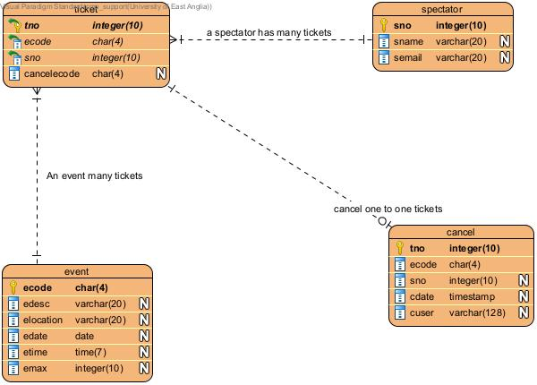

Assumptions: Cancel (ecode,tno,sno) retains the record for only the ecode tno , while ecode in from primary table Event gets deleted in when event gets deleted, tno gets too deleted in the cascade relationship with event.In view of the requirement to retain the cancelled tickets no constraint on tno,ecode to respective event,ticket table.